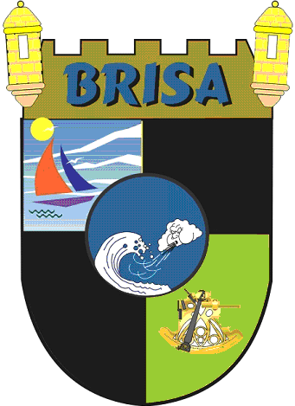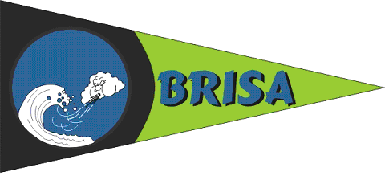
BoRinquen Islands Sailing Association
BRISA
www.brisaweb.net

March 20, 2014

Sailing Instructions Amendment 1

Class flags will be as follow:

Class Division Flag

A CSA Racing A Green

B CSA Racing B White

C Jib & Main Gray

D Nativos 17' N-17

E J-24 Class Flag

F RAYA Purple

David Kerr

Race Committee Chairman

